Q1

Estimate the mass entrainment rate in kg/s at z = 2.3 m using the Zukoski axisymmetric plume correlation ( ) for the fuel base located in the **corner** of a room as shown below. Note that the convective heat release rate is 104 kW for the given wedge shape fuel surface area (with a 45o angle). Round your answer to the second decimal place without any unit. 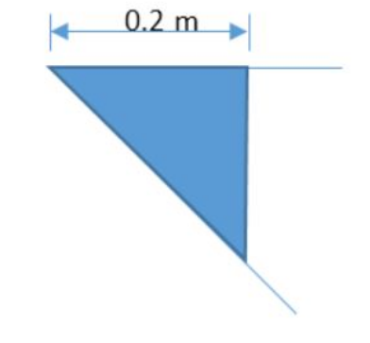

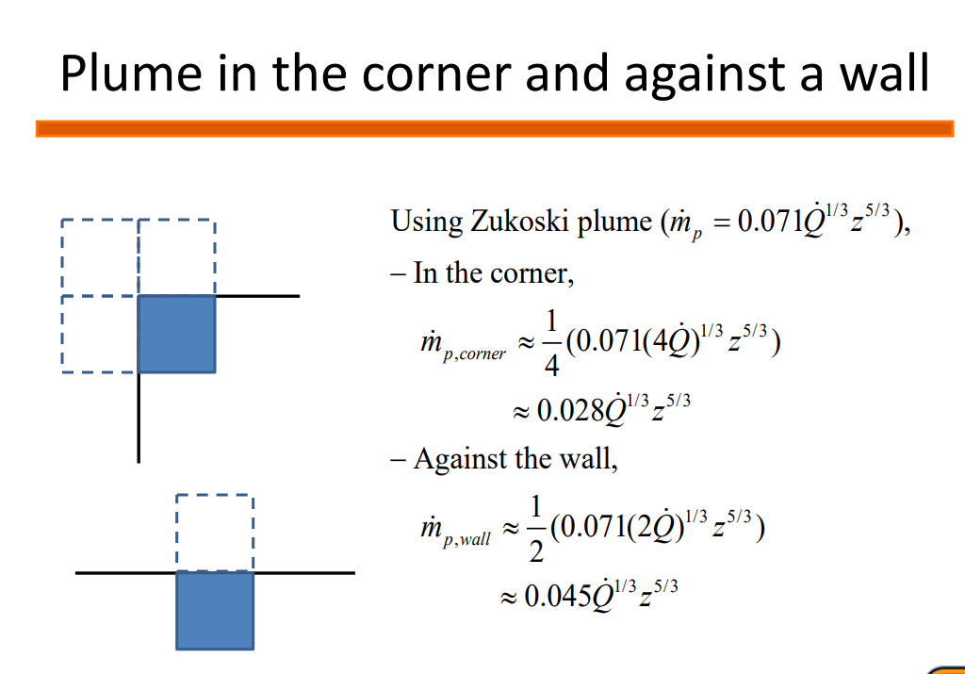



Q2&3

Calculate the plume centerline temperature and plume centerline velocity in Kelvin at 3.5 m above the fuel base for the following condition using the Heskestad’s plume correlation. Write down your answer rounded to the nearest tens without units.

* Heptane fire in a circular pan having a 0.5 m diameter
* Heat of combustion of heptane = 44.6 [kJ/g]
* Mass burning rate per unit area for infinite diameter = 0.101 [kg/m2-s]
* Extinction coefficient multiplied by the mean beam length corrector = 1.1 [1/m]
* Convective fraction of HRR = 0.7
* Ambient temp. = 20 C





Q4

Calculate the maximum possible RTI [m0.5s0.5] of a sprinkler head to satisfy the following conditions. Round your answer to the nearest ones without units.

* Sprinkler activation temperature = 57o
* Sprinkler activation time less than 1 minute.
* Sprinkler is located 3 m away from the center of a 1 m diameter kerosene pool fire on a 6 m high ceiling.
* Ambient Temp. = 25 oC
* Kerosene’s heat of combustion = 43.2 kJ/g
* Kerosene’s mass burning rate per unit area for infinite diameter = 0.039 [kg/m2-s]
* Extinction coefficient multiplied by the mean beam length corrector = 3.5 [1/m]

